MATLAB scripts
for smFRET data analysis

Table of Contents

- About the scripts
- Installation
- How to check smFRET distribution
- How to view smFRET traces

1. About the scripts

After .PMA files are analyzed by the IDL scripts, .PKS files and .TRACES files are generated. Although these files contain all the necessary information (the position of fluorescent molecules, the donor and the acceptor intensity of each molecule at each frame), a tool that reads and shows them in user-friendly format is required.

As the “tool”, MATLAB (The Mathworks, Inc.) is chosen, and this manual documents two MATLAB scripts written for smFRET data analysis. Eventually, people would write more and more scripts to do the analysis that they want, but these two scripts will remain the most useful and frequently used ones.

This manual is written using MATLAB R2008a, but MATLAB 5 and higher versions work well with the two scripts introduced here.

2. Installation

1) Download and unzip the “MATLAB.zip” where you want. In this example, “C:\User\MATLAB\”

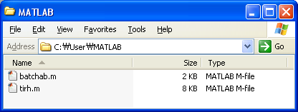

2) Add “C:\User\MATLAB\” directory, or the directory you want to MATLAB search path.

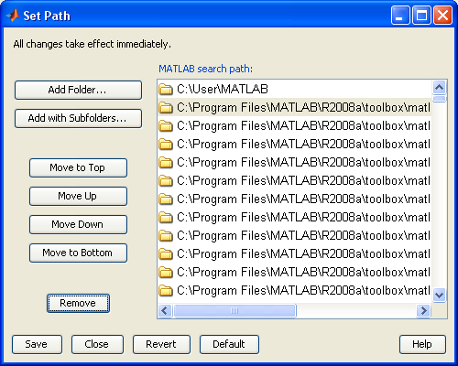

3. How to check smFRET distribution

0) .TRACE files to be used for this script should be longer 12 frames. It is because the FRET value and the intensity value of each molecule are set as the average value of them from the frame 3 to frame 12. (To be safe, the first 2 frames are discarded.)

1) In order to build a histogram of FRET distribution, first you need to collect many molecules. Usually, FRET distribution is built from more than 20 .TRACE files, where each of them contains ~600 molecules. In this example, only 10 .TRACE files are used.

2) Create a directory and move all the .TRACE files from which FRET distribution is built into the directory. In this example, “C:\User\tir data\example2\#1 sample_histogram\”

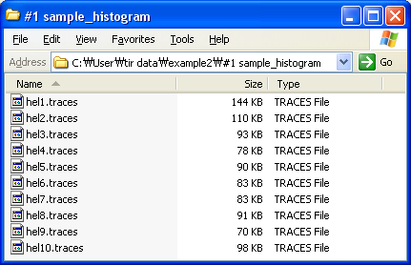

3) Launch MATLAB.
From now on, “MATLAB> something ” means, type something at the MATLAB prompt.

4) MATLAB>batchab

It asks you to choose a directory. In this example, “C:\User\tir data\example2\#1 sample_histogram\” is chosen. So,

MATLAB> ‘C:\User\tir data\example2\#1 sample_histogram\’
Don’t forget quotation marks.

5) Two figure windows will pop up.

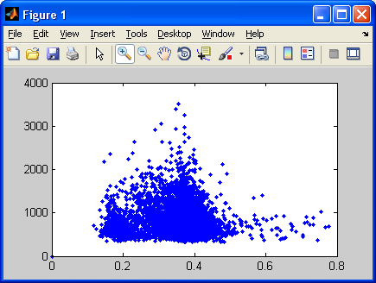
Figure 1 is FRET vs Intensity plot. Each blue dot indicates each molecule. X-axis is FRET and Y-axis is intensity (donor intensity + acceptor intensity).

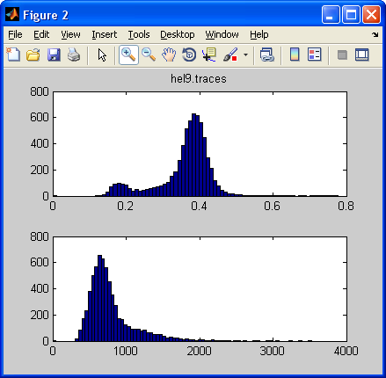
Figure 2 is FRET and intensity histogram. The top one is FRET histogram, and the bottom one is intensity histogram (donor intensity + acceptor intensity). For your information, the title of this plot, “hel9.traces” in this example, is just the name of the .TRACE file that was read in last, which is not important at all.
6) Also, it asks “low cutoff intensity” and “high cutoff intensity”

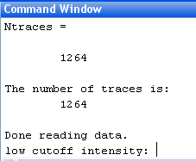

Usually, there are some junk peaks among the molecules found in .PMA files, and they are usually outliers in intensity distribution histogram. Therefore, in order to get “cleaner” smFRET distribution, we set “low cutoff intensity” and “high cutoff intensity”. All the molecules with lower intensity than the “low cutoff intensity” or with higher intensity than the “high cutoff intensity” are omitted in plotting smFRET distribution.

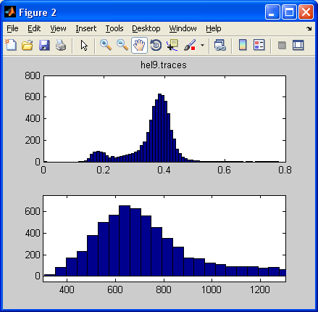

In this example, I chose, “400” and “1200”.

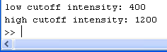

7) Then, the Figure 2 is updated.
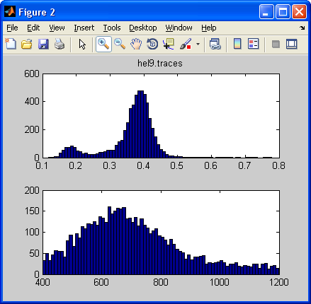

In this example, “cut off” did not change the shape of smFRET distribution much, possibly because there were almost no junk peaks from the beginning.

8) Also, “FRET 400_1200.dat” file is created in the “C:\User\tir data\example2\#1 sample_histogram\”. Each line of this file is the FRET value and the intensity value of each molecule which was used to build the histogram in the Figure 2.
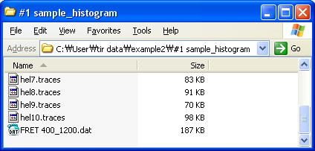
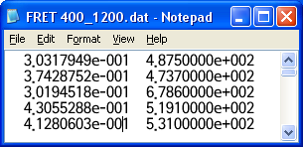
4. How to view smFRET traces

0) Again, .TRACE files to be used for this script should be longer 12 frames.

1) In this example, we will see smFRET traces of molecules in “hel43.traces” in “C:\User\tir data\example2\#2 sample trace\”.

2) Launch MATLAB.
From now on, “MATLAB> something ” means, type something at the MATLAB prompt.

3) MATLAB>tirh

4) Directory [default= pwd]
It asks you to choose a directory. In this example,

MATLAB> ‘C:\User\tir data\example2\#2 sample trace\’
Don’t forget quotation marks.

5) index # of filename [default=1]
It asks you to choose the index number of .TRACE file.

MATLAB> 43

6) Time Unit [default=0.1 sec]
It asks you to set the frame rate (kinetic cycle, the time between the start of one frame and the start of the next frame). Refer “hel43.log” file if you do not remember this value.

MATLAB> 0.03

7) Donor leakage correction [default=0]
It asks you to set the donor leakage correction. Donor leakage is the ratio of “the donor signal detected in the acceptor channel” to “the real donor intensity”. Ideally, none of donor signal should be seen in the acceptor channel, but due to spectral overlap of donor and acceptor emission, some “leakage” is inevitable. However, once we know the “donor leakage”, we can correct for it. In our setup, the donor leakage is ~0.15.

MATLAB> 0.15

8) A figure window that shows smFRET trace pops up.

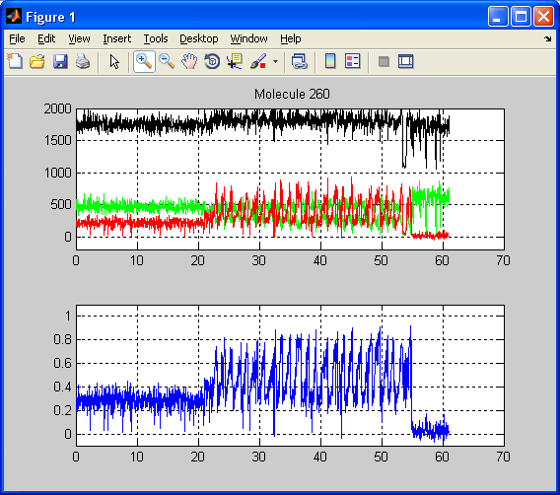

The title of the plot, “Molecule 260”, is the index of the molecule. The top one is time vs intensity plot. X axis is time in second, and Y axis is intensity in arbitrary unit. Green, red and black line are donor intensity, acceptor intensity and 1000 + sum of donor and acceptor intensity, respectively. The bottom one is time vs FRET plot. X axis is time in second, and Y axis is FRET.

9) Note that two files are created. “43_avg.dat” and “43_elevel_10p.dat”

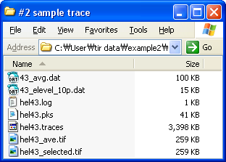
“_avg.dat” is the average intensity trace of all the molecules in the file. The script averages the donor intensity and the acceptor intensity of all the molecules for each frame.
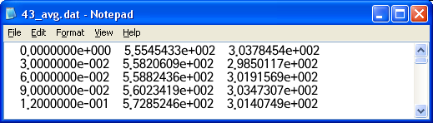
Column 1: Time in seconds
Column 2: Average donor intensity
Column 3: Average acceptor intensity

“_elevel_10p.dat” stores the average FRET and the average total intensity (sum of donor and acceptor) of all the molecules. The average is taken from frame 3 to 12 for each molecule.
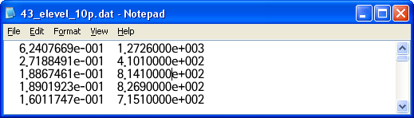
Column 1: Average FRET
Column 2: Average total intensity

Keymaps

<x><Enter>
End the script.

<Enter>
Move to the next molecule.

<b><Enter>
Move backward. Go back to the previous molecule.

<f><Enter>
Move 10 molecules forward.

<g><Enter>
Go to a certain molecule.
When prompted with “which molecule?”, type the molecule No. that you want to view.

<k><Enter>
Background subtraction. You have to click two points in the top plot, time vs intensity plot, with left mouse button, and press <Enter>. Then Y position (intensity) of the point you click is taken as background signal, and it will be subtracted from the trace, and the plot will be updated after the subtraction. The first click is for the donor background (green trace) and the second click is for the acceptor background (red trace).

<s><Enter>
Save the trace of the current molecule as an ASCII text file. The filename is “index No. of .TRACE file” + “ tr” + “molecule No.” + “.dat”, in this example, “43_tr260.dat”
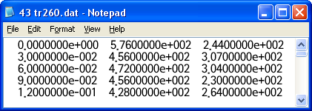
Column 1: Time in seconds
Column 2: Donor intensity
Column 3: Acceptor intensity

